**DANCE: Year 9 Knowledge Organiser**

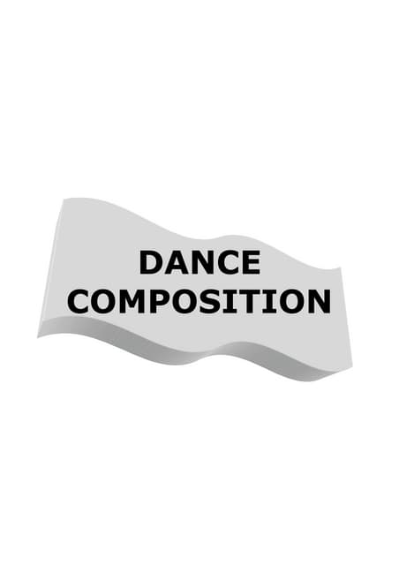

**Professional Repertoire: Some Like It Hip Hop**

* Choreographed by Kate Prince in 2011
* Students will learn two pieces of repertoire from the professional work and will take part in a series of creative choreographic workshops in the style of ZooNation.

**Different types of stimuli**

Auditory: What does it sound like?

Visual: What can you see?

Kinaesthetic: How does it move?

Tactile: How does it feel?

Ideational: What is its job?

**The elements of dance**

**Action** – Elevation, gesture, turn, travel, stillness

**Space** – The ‘where’ of movement; levels, directions, pathways, size of action & formation

**Dynamics** – Degrees of speed, force and flow that creates the quality of the movement

**Relationships** – The ways in which dancers interact and connect with one another.

**Motif** – A single movement or short phrase, which has the potential to be developed

**Motif development:** The adaption, variation and extension of the motif through ASD&R

**Form/Structure:** The order in which a dance is put together

**Rondo** (ABACADA) - ‘A’ is the chorus and is repeated after each different verse.

**Ternary** (ABA/ABA) - a contrasted middle section where the beginning is either repeated exactly the same or is presented as a modified version.

**Binary** (AB) - two contrasting sections

**Narrative** (ABCDEF) – Movement content is sequentially arranged into separate sections; this could be to tell a story.

**Theme and variation** (A1,A2,A3) – Each section builds and develops from the section before. The theme provides a basis for the variation and each variation becomes the theme for the next variation.

**Performance skills:**

**Projection** - Confident presentation of one’s body and energy to communicate movement and meaning

**Musicality** - The ability to be receptive to rhythm, tempo and mood when dancing.

**Energy-** Amount of dynamic force and the qualities of the movement

**Focus** - Use of eyes to enhance performance / where eyes are directed.

**Facial Expression** – A gesture executed with facial muscles to communicate mood, feeling or character.

**Emphasis-** The accents in energy and timing provided by the dancer at different moments throughout the dance.

**Commitment-** The level of dedication to the performance role

**Timing-** Use of time/counts to match movements to sound.

**Spatial awareness** - the ability to see objects in relation to each other and to oneself.

**Compositional devices**: tools used to develop movement

**Unison**- Two or more dancers doing the same movement at the same time

**Canon**- Movement performed at different times, one dancer followed by another

**Lead & Follow**- One dancer following the pathway of another

**Question & Answer**- One dancer performs, and the other dancer performs a movement that ‘replies’

**Repetition**- An action or sequence that occurs again

**Retrograde-** The motif performed backwards, as though rewound

**Mirroring**- Dancers reflecting movement as a mirror image

**Numerical Variation**- Grouping dancers (2:2 duet, group 3:1, 6:2)

**Pathway**- Direction of travel to create spatial designs and patterns

**Formation-** The spatial positioning of the dancers (lines, circles)

**Accumulation-** Repeating a phrase with a new movement each time

**Fragmentation**- The phrase is broken down into smaller parts and reordered

**Embellishment**- Detail is added to the original movement

**Physical skills**:

**Balance**- Arrangement of body parts to create equal distribution of weight

**Alignment**- Placement of body parts in relation to one another

**Strength**- Withstand or exert force with muscle power

**Isolation**- Independent movement of a single body part

**Control**- Engagement of muscles to start, stop, change direction and hold shape with accuracy

**Stamina**- Sustain prolonged physical activity requiring muscular and cardio-respiratory endurance

**Posture**- Carriage of the body and the way in which its held

**Extension**- The lengthening of limbs

**Coordination**- Effective combination of movement from various body parts

**Flexibility**- Range of movement in the joints and the lengthening of muscles across the joints

**Mobility**- Moving fluently from action to the next